INOVA WEB APPLICATION TESTING PROCESS TRAINING MODULE

- Training>Training Program:

Training module from date and to date validation is not performed properly. Please check.

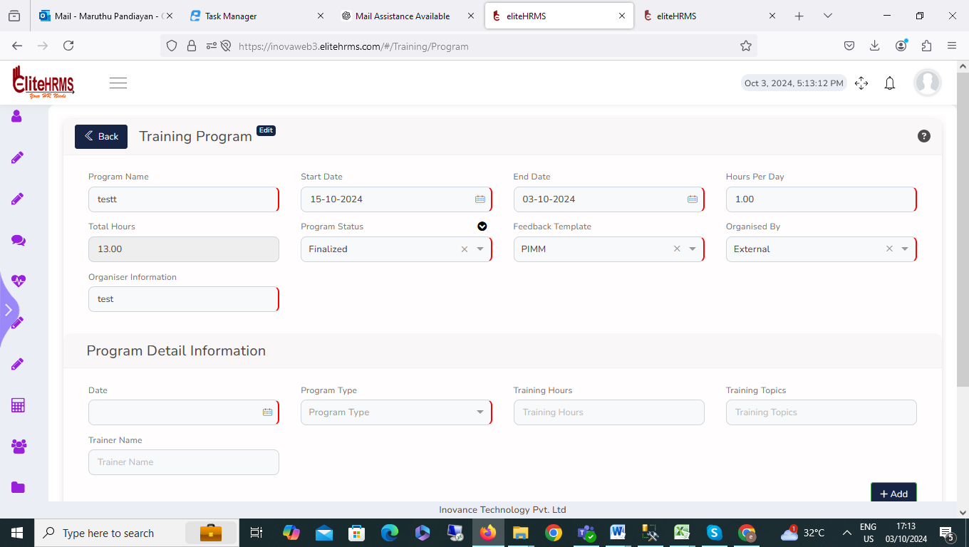

- Training>Training Program:
I encountered an issue on the Training Program search page. When I select the Feedback Template and click the search button, an error message is displayed. Could you please check this issue?
Response | Object { _status: "Failed", _code: "999", _Source: "PostReportResult", … }
_status | "Failed"
_code | "999"
_Source | "PostReportResult"
_Description | "Exception Occurred"
_Details | "Error converting data type nvarchar to int."
_TransID | null
_Timestamp | "20241003175209"
ColumnList | []
PageGridResultJson | []
PageGridResult | []
pageInfo | Object { TotalPageCount: null, PageNo: null, PageSortBy: null, … }
TotalPageCount | null
PageNo | null
PageSortBy | null
PageSize | null

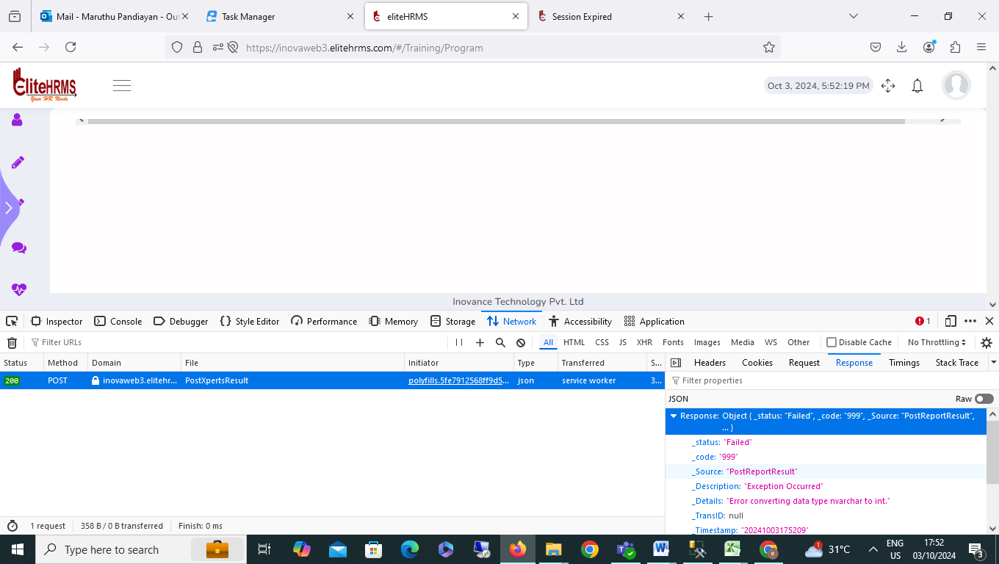
3. Program Allocation> Employee Selection:
1. I encountered an issue on the Employee Selection Screen. After selecting employees and clicking the save button, the system is inserting multiple records for the same employee based on the employee code. Could you please check?

2. I am facing an issue with the Employee Selection Screen. The location, department, and unit filters, as well as the load employee search, are not functioning as expected.
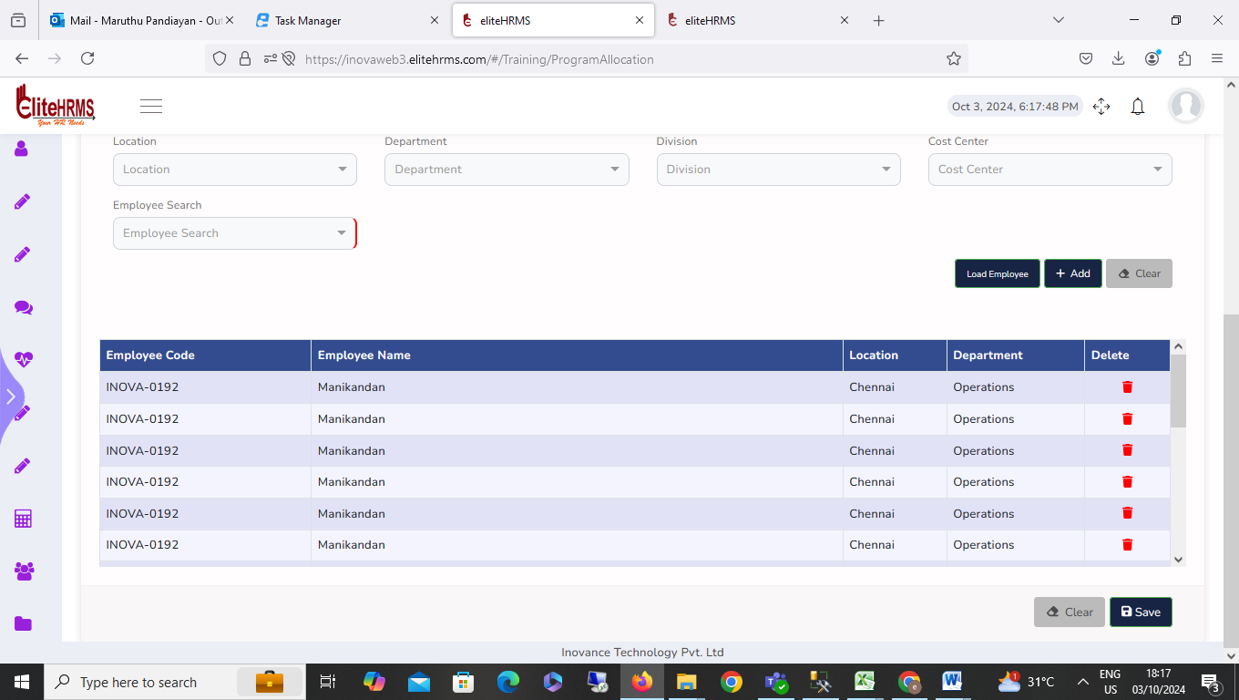

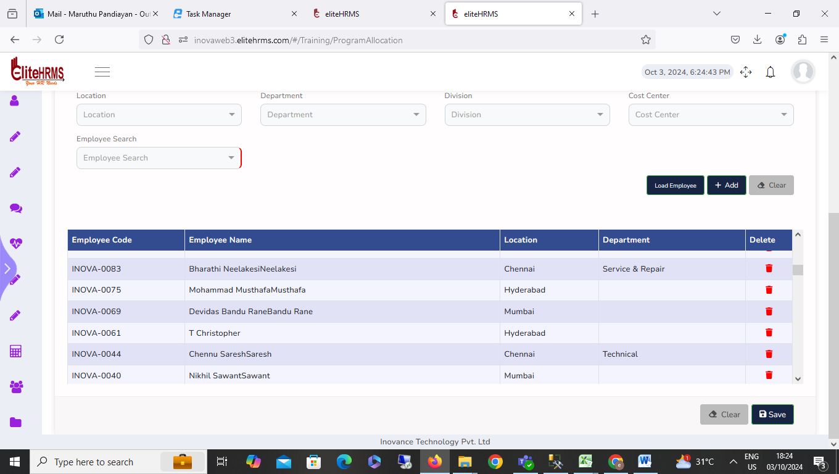
4.Program Allocation> Employee Feedback Form:
Employee Feedback Form employee code details below status details not visible. Please check.
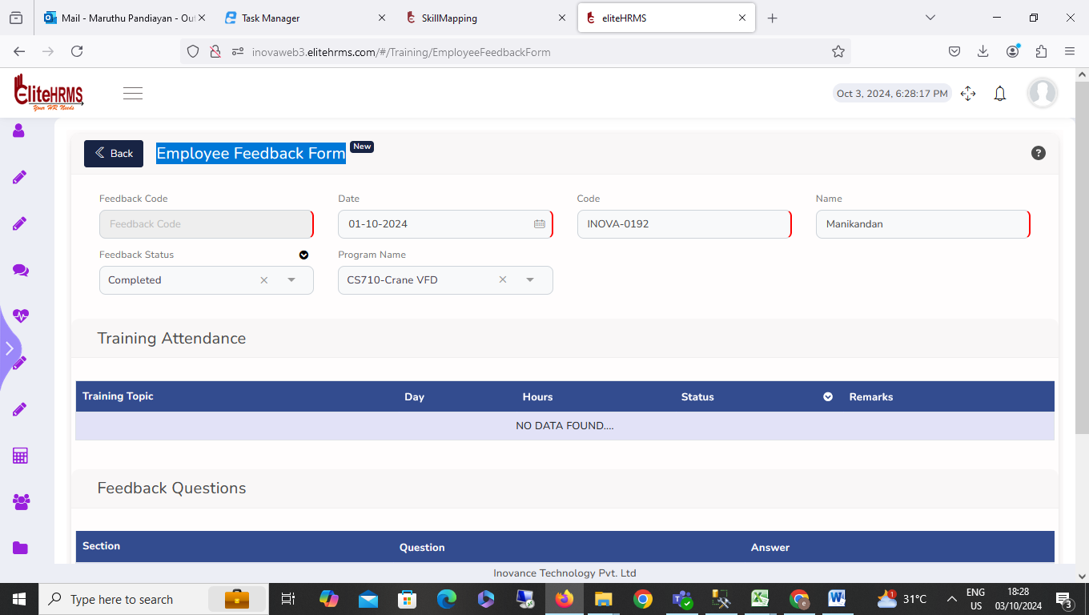

5. Program Allocation> Review Training Program:
I am facing an issue with the Review Training Program. The Feedback Template, and Organized by filters, Options not working
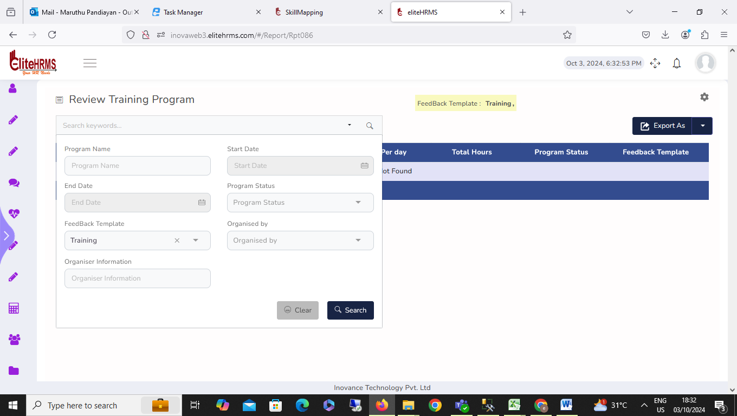
6. Program Allocation>Review Feedback Template:
Review Feedback Template report screen working fine, no issue.
7. Program Allocation>Review Feedback Question:
Review Feedback Question report screen working fine, no issue.
8. Program Allocation> Review Training Program Allocation:
I am facing an issue with the review training program allocation. The search button filters clicked, multiple records showed, please check.

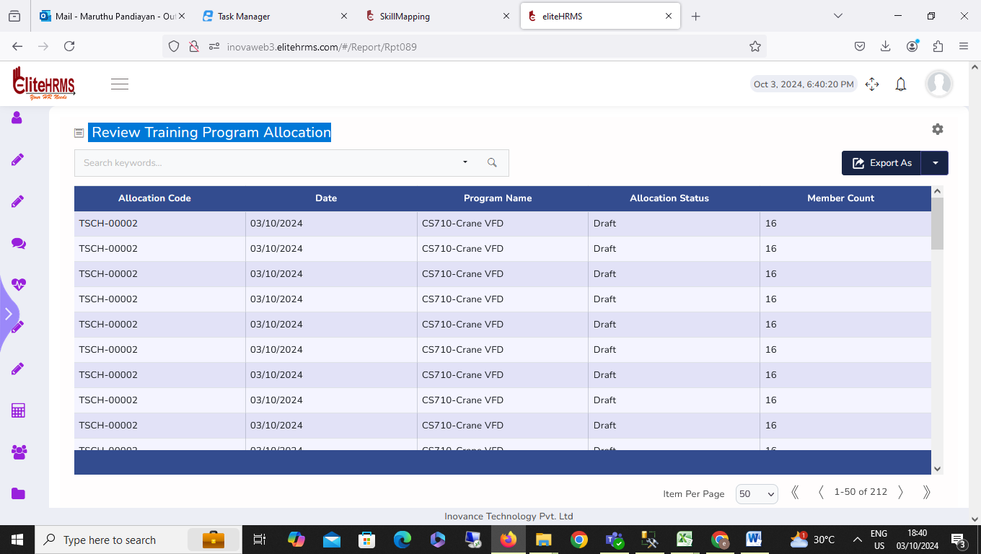

9. Program Allocation> Review Employee FeedBack:
Employee Feedback Form employee code details below status details not visible. Please check.

